

Students – How to set up Parent Proxy

Go to mynova.villanova.edu

Search for “Parent Proxy”

Step 1: Click on “Add Proxy”

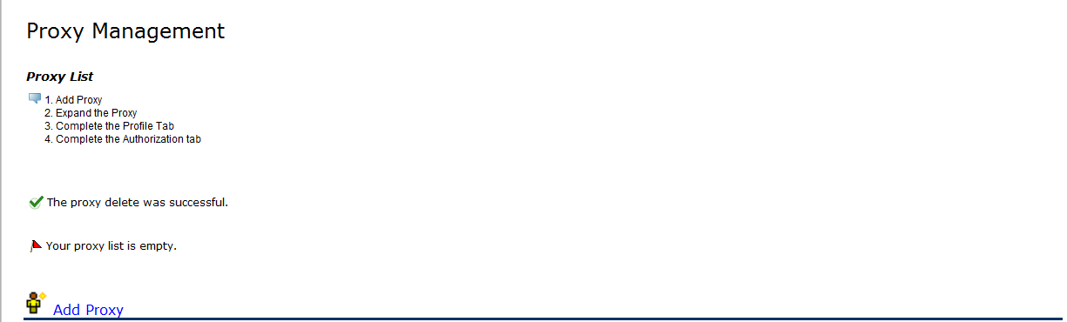

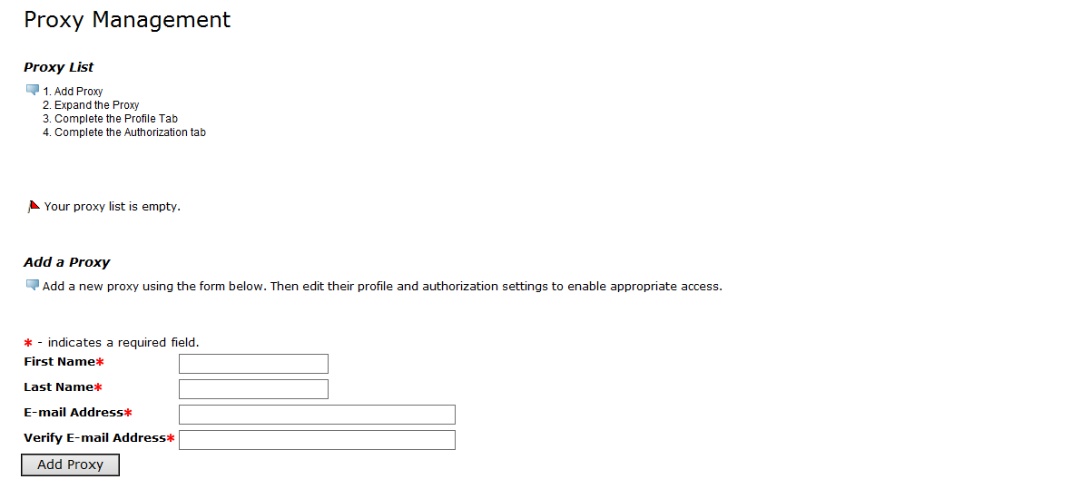

Step 2: Type First Name, Last Name and email address for your proxy who will be able to access your information.

You must click “ADD Proxy”

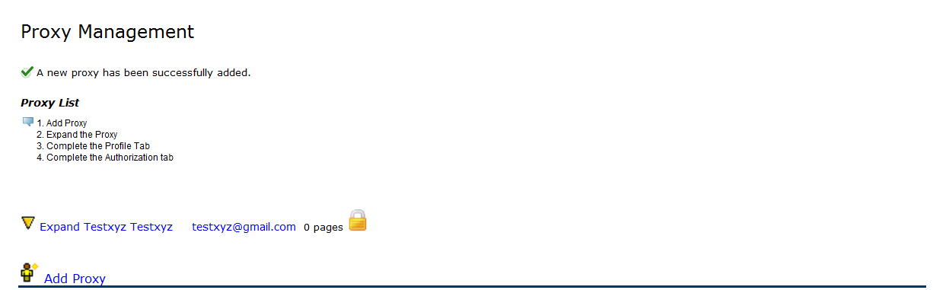

jsm@gmail.com

Joe Smith SmSs=SmSmithSSmith

Do not add another proxy until you complete Steps 4 and 5 for your First Proxy.

Step 3: The lock next to the proxy name means you need to complete the authorization process. Click on your proxy name.

You will see this comment if your proxy has been added.

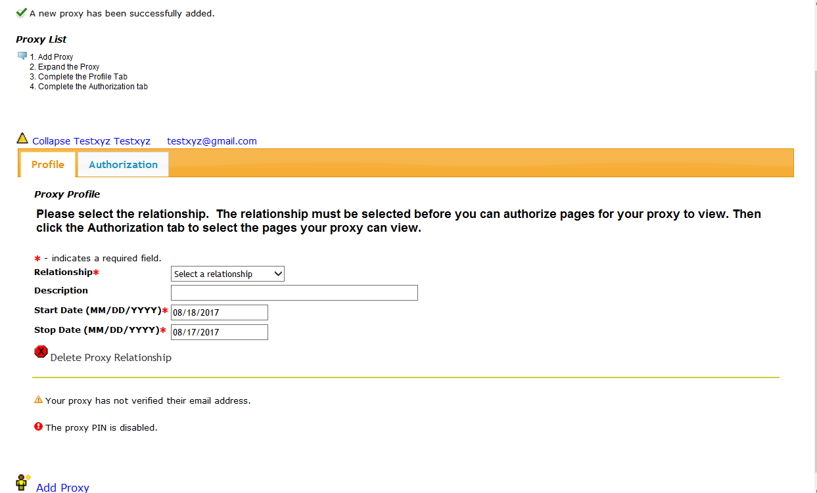

Step 4: Complete the Profile Tab first. Choose your relationship. You may set your end date to the year you are due to graduate. There is no submit button.

Step 5: Click on the Authorization Tab.

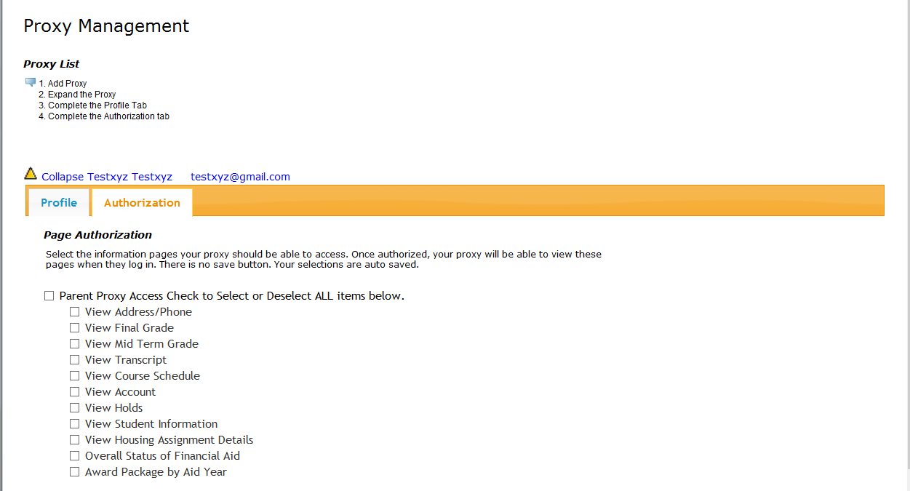

Step 6: Select the boxes that correspond to the information you want to share with your proxy. Your selections are auto saved. If you want to add another proxy, click the “Add Proxy” Icon at the bottom of the page.